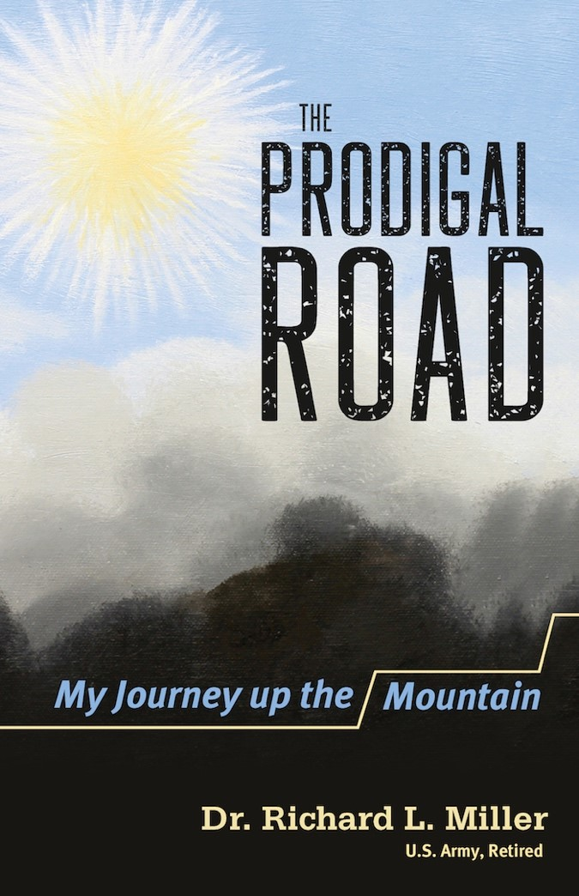
- Release Date: October 26, 2017
- ISBN: 9781632694508
- Retail: $16.99
- Pages: 352
- Category 1: Spiritual Warfare
- Category 2: Personal Memoir
- BISAC: REL099000 RELIGION / Christian Life / Spiritual Warfare
- Format: softcover

THE PRODIGAL ROAD
MY JOURNEY UP THE MOUNTAIN

DR. RICHARD L. MILLER

The Prodigal Road is the personal story of the rescue of an exuberant young man who became entrapped in the deceitful clutches of evil. Dr. Richard Miller—
the author and subject of the book—interweaves the antics, joy, and pain of a preacher’s kid exploring the hills of Appalachia and imagining the thrill of exploring faraway places.
However, due to a poor relationship with his father and his own stubborn will, he drifted into a life of rebellion punctuated by a near-fatal bout with alcohol poisoning. While he pursued a successful military and corporate career, an invisible war raged in the background of his life, tormenting him with fear of punishment from an angry God for not becoming a preacher. At age 35, Richard found himself in Siam, where the Shepherd was waiting, not to punish him, but to forgive him and saturate him with the exhilarating joy of unequivocal love! From this beginning, he learned to ingest God’s word, which released its dynamic power in his life as the permanent remedy for fear, anxiety, and stress. This book will help you acquire that same peace.
Take the journey with Richard as he moves from the dark swamp of rebellion—where he was hammered by the king of the swamp—and climbs the mountain of redemption where he is captured in the majestic light of the Redeemer. The hero of the story is the Redeemer who forgives and then provides dynamic lessons of God’s words that will permeate one’s heart, soul, and mind to create congruence among all aspects of life.
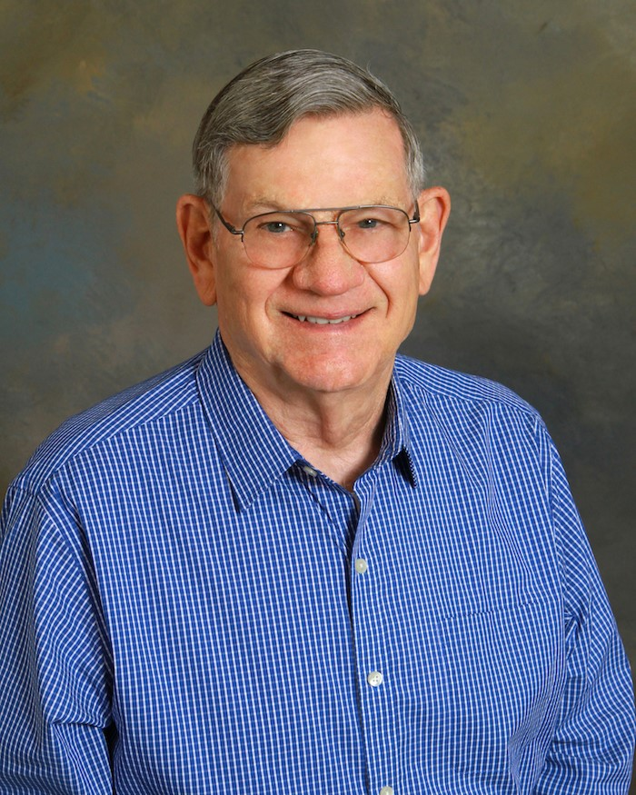
About the Author
DR. RICHARD L.
MILLER
Dr. Richard Miller’s parents instilled in him a passionate love of country and adoration of the beauty of God’s universe. As a boy he became an avid adventurer and passionate learner, and dreamed of serving his beloved America as a soldier and seeing the world. The US Army facilitated both dreams. His 23-year
career as a Field Artillery officer saw him traveling to Korea, Japan, Germany, Austria, France, Vietnam, and Siam.
Richard’s insatiable desire for learning led to a Bachelor of Science in
Electrical Engineering, a Master of Science in Bio Environmental
Engineering, and a Doctorate of Strategic Leadership. He was thrilled to engage in exploratory research pushing the state-of-the-art in radar and remote vehicle control for the US Army. His passion for helping young people reach their highest potential was instrumental in the successful expansion of a corporate firm tenfold by mentoring new employees in the philosophy of excellence. He is now retired and living in Goldsboro, North Carolina, with Jenny, his wife of 56 years. They have three children and five grandchildren.

